Malaria Indicator Survey

Household Listing Manual

ICF International
Rockville, Maryland

March 2016

CONTENTS

I. Introduction.................................................................................................................2
II. Responsibilities of the listing staff..............................................................................3
III. Definition of terms......................................................................................................4
IV. Locating the EAs.........................................................................................................5
V. Preparing location and sketch maps..............................................................................6
VI. Collecting a GPS waypoint for each cluster ..................................................................7
VII. Listing the households..................................................................................................8
VIII. Segmentation of large EAs.........................................................................................9
IX Quality control..........................................................................................................11
X. Appendix 1. Example of symbols suggested for mapping.....................................12
XI. Appendix 2. Examples of mapping and listing forms..............................................13
XII. Appendix 3. Example of household listing form........................................................15
XIII. Appendix 4. Example of segmentation form............................................................16

- Introduction

The Malaria Indicator Survey (MIS) is a multipurpose survey. Its main indicators relate to: at the household level, ownership and use of insecticide-treated nets (ITN); for individuals, the diagnosis and treatment of children under five years with fever in last two weeks; and women who received intermittent preventive treatment (IPTp) for malaria during their last pregnancy. There is also a section in which biomarker testing is done to measure anemia and malaria parasitemia in children 6 to 59 months of age. Therefore, the target population for an MIS is defined as households, women of reproductive age (15-49), and children under five years of age living within malaria endemic or epidemic-prone areas. The survey will interview every woman age 15-49 in the households randomly selected from a set of sample points that are clusters of households. Before the interviewing begins, all households located in the selected clusters will be listed. The listing operation consists of visiting each of the selected clusters, recording on listing forms a description of every structure together with the names of the heads of the households found in the structure, and drawing a location map of the cluster as well as a sketch map of the structures in the cluster.

The listing operation represents an appreciable field cost, but there is no reliable method by which it can be avoided. As stated in the Section 10 of the MIS sampling manual [1], the listing operation represents one of the most important bias correction procedures in the survey, especially when the sampling frame is out-of-date. The listing operation will provide complete and recent information on the number of residential households, households occupied, and households vacant. These kinds of information are necessary for household selection to reduce non-sampling errors. The listing of households for each cluster will be used in selecting the final sample of households to be included in the MIS survey.

To ensure the quality of the household listing, this manual will briefly discuss the responsibility of the listing staff, the definition of terms, the locating of the clusters, drawing sketch maps of the clusters, listing the households, segmentation of large clusters, and the listing quality control. For more details of the household listing operation, refer to the DHS Sampling and Household Listing Manual.

II. Responsibilities of the listing staff

Persons recruited to participate in the listing operation will work in teams consisting of two enumerators. A coordinator will monitor the entire operation.

The responsibilities of the coordinator are to:

1) Obtain base maps for all the clusters included in the survey
2) Arrange for the reproduction of all listing materials (listing manuals, mapping, and listing forms)
3) Assign teams to clusters
4) Obtain travel allowances for the teams
5) Arrange for transportation of the teams to the field
6) Monitor the reception of the completed listing forms at the central office
7) Verify that the quality of work is acceptable.

If GPS coordinates are being collected during the listing operation, the coordinator must also:
- Obtain one GPS receiver per listing team, plus two backup receivers, and tag each GPS receiver with a number
- Ensure that all GPS receivers have the correct settings (see Section 2.6 below) and distribute a receiver to each field team
- Obtain and copy all GPS training materials for listing staff
- Train all listing staff to record GPS waypoints in the GPS units
- Provide troubleshooting assistance to listing staff
The responsibilities of the enumerators are to:

1) Contact local officials in each cluster to inform them about the listing operation and to obtain their cooperation
2) Identify the boundaries of the cluster
- Draw a sketch map showing the location of the cluster
- Draw a detailed sketch map of the cluster
5) List all the households in the cluster in a systematic manner
6) Communicate to the coordinator problems encountered in the field and follow his/her instructions.

If GPS coordinates are being collected during the listing operation, enumerators must also:

- Capture and record the GPS waypoint of the center of the cluster
- Complete the form designated for GPS information for each cluster

The two enumerators in each team should work at the same time in the same area. They identify the cluster boundaries together, and then one enumerator prepares the location and sketch map, while the other does the household listing. The sketch map and the household listing form must be prepared in tandem.

The materials needed for the household listing operation are:
- This manual
- A base map of the area containing the cluster
- Map Information Form (Form MIS/1)
- Household Listing Form (Form MIS/2)
- Segmentation Form (Form MIS/3)
- GPS receivers, batteries and cables
- GPS training manuals and handouts

III. Definition of terms

The basic documents for household listing usually come from the General Household and Population Census (GHPC) completed in a country in a recent year.

An enumeration area (EA) is the smallest geographical statistical unit created in the GHPC.

A base map is a reference map that contains one or more EAs. It shows the boundaries of the EAs and the principal physical features and landmarks such as mountains, rivers, roads, and electric poles.

A cluster is the smallest geographical statistical unit, which is an EA or a part of an EA.

A dwelling unit is a room or a group of rooms normally intended as a residence for one household (e.g., a single house, an apartment, or a group of rooms in a house).

A structure is a free-standing building that can have one or more rooms for residential or commercial use. Residential structures can have one or more dwelling units (e.g., a single house or an apartment building). In the case where one household inhabits several small dwellings, as in a rural area, all the dwellings together, whether they are fenced in or not, constitute a structure.

A household consists of a person or a group of related or unrelated persons, who live together in the same dwelling unit, who acknowledge one adult male or female 15 years old or older as the head of the household, who share the same housekeeping arrangements, and who are considered to constitute one unit. In some cases one may find a group of people living together in the same house, but each person has separate eating arrangements; they should be counted as separate one-person households. Collective living arrangements such as army camps, boarding schools, or prisons will not be considered as households. Examples of households are:

- A man with his wife or his wives with or without children
- A man with his wife or his wives, his children, and his parents
- A man with his wife or his wives and his married children living together for some social or economical reasons (the group recognizes one person as the household head)
- An unmarried man or woman with his or her children who provides their living essentials and foods
- A widowed or divorced man or woman with or without children

The head of household is the person who is acknowledged as such by members of the household and who is usually responsible for the upkeep and maintenance of the household.

IV. Locating the EAs

The coordinator will provide the listing team with a base map containing the EA assigned to the team. Upon arrival in an EA, the team should contact the local authorities living in the vicinity and request assistance to identify the boundaries of the EA. In most cases, the boundaries follow easily recognizable natural features such as streams or rivers, and construction features such as roads or railroads. In some cases, the boundaries may not be marked with visible features (especially in rural areas). In these cases, attention should be paid to carefully locating the EA using the detailed description file for the EA.

Before doing the listing, the team should tour the EA to determine an efficient route of travel for listing all the structures. Divide the EA into parts if possible. A part can be a block of structures. It is useful to make a rough sketch map of the EA indicating the boundaries of the parts, as well as the relative location of landmarks, public buildings (e.g., schools, temples, public offices, and markets), and main roads. This rough sketch will serve as a guide for the interviewing team when they begin data collection.

V. Preparing location and sketch maps

The coordinator will designate one enumerator of the team as the mapper. The second enumerator will be the lister. Although the two have separate tasks to perform, they must move together and work in tandem; the mapper prepares the maps, and the lister collects information on the structures (and corresponding households) indicated on the sketch map.

The mapping of the EA and the listing of the households should be done in a systematic manner so that there are no omissions or duplications. If the EA consists of a number of blocks, then the team should finish each block before going to the adjacent one. Within each block or village, start at one corner of the block or village and move clockwise around the block. In rural areas where the structures are frequently found in small groups, the team should work in one group of structures at a time, and in each group they can start at the centre (choosing any landmark, such as a school, to be the centre) and move around it clockwise.

On the first page of the MIS Survey Map Information Form (Form MIS/1, see
Appendix 2), the mapper will prepare a location map of the cluster by first filling in the identification box for the cluster. All information needed for filling in the identification box is provided by the coordinator. In the space provided, draw a map showing the location of the EA and include instructions on how to get to the EA. Include all useful information to find the EA and its boundaries directly on the map and in the space reserved for observations if necessary.

On the second page of Form MIS/1, draw a sketch map of all structures found in the EA. It is important that the mapper and lister work together and coordinate their activities, because the structure numbers that the mapper indicates on the sketch map must correspond to the serial numbers assigned by the lister to the same structures.

On the sketch map, mark the starting point with a large X. Place a small square at the spot where each structure in the EA is located. For any nonresidential structure, identify its use (e.g., a store or factory). Number all structures in sequential order beginning with "1." Whenever there is a break in the numbering of structures (e.g., when moving from one block to another), use an arrow to indicate how the numbers proceed from one set of structures to another. Although it may be difficult to pinpoint the exact location of the structure on the map, even an approximate location is useful for finding the structure in the future. Add to the sketch map all landmarks (e.g., park), public buildings (e.g., school or church), and streets or roads. Sometimes it is useful to add to the sketch map landmarks that are found outside the EA boundaries if they are helpful in identifying other structures inside the EA.

Use the marker or chalk provided to write on the entrance to the structure the number that has been assigned to the structure. Remember that this is the serial number of the structure as assigned on the household listing form, which is the same as the number indicated on the sketch map. To distinguish the number from other numbers that may already exist on the door of the structure, write MIS in front of the number. For example, on the door of structure number 3, write MIS/3, or on the door of structure number 54, write MIS/54.

VI. Collecting a GPS waypoint for each cluster

A GPS waypoint is a latitude and longitude reading that represents a location. For some surveys, GPS data for EAs are available from the census. However, if the data are not available, or are of questionable quality, one GPS waypoint for each cluster should be recorded during the listing phase of the survey. These waypoints are recorded using a GPS unit (a Garmin ETREX unit is used in this guide) and data collection forms. If GPS units other than the Garmin ETREX are used, this guide will still be useful; however, some of the instructions may not apply due to differences in design and menus. The Garmin ETREX owner’s manual may be useful to consult on the basics of the GPS unit.
Take one reading for each cluster. The GPS waypoints will be captured by the mapper while s/he is mapping the clusters. One GPS waypoint must be taken for each cluster, and in the case of large clusters which are being segmented, one point should be taken for each segment selected for listing. In DHS surveys, clusters are usually census EAs, sometimes villages in rural areas or city blocks in urban areas. Collecting only one waypoint for the cluster greatly reduces the chance of compromising confidentiality of the respondents and at the same time is sufficient to allow for the integration of multiple datasets for further analysis. The DHS cluster waypoint should always be taken at the geographic center of the cluster or segment. If the cluster is segmented, the point should be taken for the segment chosen by the Mapping and Listing Coordinator to be included in the survey.
Save the waypoint and record the latitude, longitude, and altitude. The latitude, longitude, and altitude reading for a location are stored in two places: in the GPS unit’s memory and on the DHS/1 paper form. GPS units can be broken or lost, and experience has shown that a hardcopy backup is essential. In addition, the paper form provides a backup should the data in the GPS unit be changed, deleted, or misidentified (i.e., the operator names the cluster incorrectly in the unit). Each position saved in the GPS unit is called a waypoint, and each waypoint has a unique name. If possible, the waypoint ID should be the same as the DHS cluster number. If it is not possible, the waypoint ID should be unique to the cluster and recorded on Form DHS/1 (do not record the same waypoint ID for two different clusters). When a waypoint is saved, the GPS unit assigns it a default name. The mapper must edit the default name and change it to the 6-digit DHS cluster ID number. For example, the waypoint for DHS cluster 101 would be named “000101”. Cluster 1101 would be named “001101”. After saving the waypoint, the mapper will use the identification box of the Map Information Form (Form DHS/1) to record the latitude, longitude, and altitude for the cluster and segment on paper. First, the mapper will write down the latitude and longitude coordinates in decimal degree format and altitude in meters in the Identification Box on the “Location Map Cluster” Form (DHS/1). Second, the mapper will draw a circle, in the middle of the cluster/segment, at the location where he/she captured the waypoint.
After all cluster listings are complete, the GPS units must be collected as soon as possible and returned to the sampling office by the Mapping and Listing Coordinator. The waypoints will then be downloaded and examined for problems by the designated sampling staff. The Sampling Coordinator should designate one member of the Data Processing Team to receive and process the GPS waypoint file and then give the file to survey manager.
In most situations, the Mapping and Listing Coordinator will be responsible for providing the listing teams with a GPS unit prior to the listing. Before these units are distributed they should be set up for use by the listers. For DHS surveys, the only format which is acceptable is Decimal Degrees, regardless of what geographic standards may be in use for other purposes. To set the format, enter the SETUP menu and in the UNITS sub-menu, select the item POSITION FRMT and press the ENTER button. Select “hddd.ddddd” Decimal Degrees, which is the first item. Once “hddd.ddddd” is highlighted, press the ENTER button. It is important that all the GPS units be set up in the same way so that the waypoints returned at the end of the survey are all in the same format. For more details on how to properly prepare the GPS units for waypoint collection, please refer to the DHS Manual for GPS Data Collection. It is equally important to wait for the GPS units to connect to multiple satellites before taking a reading, to ensure the most accurate reading possible.

Listing the households

The lister will use the MIS Survey Household Listing Form (Form MIS/2, see Appendix 3) to record all households found in the EA. Begin by entering the identification codes of the EA; the first two columns are reserved for office use only, so leave them blank.

Complete the rest of the form as follows:

Column (1) [Serial Number of Structure]: For each structure, record the same serial number that the mapper enters on the sketch map.

Column (2) [Address/Description of Structure]: Record the street address of the structure. Where structures do not have visible street addresses (often in rural areas), give a description of the structure and any details that help in locating it (e.g., in front of the school or next to the store).

Column (3) [Residence Y/N]: Indicate whether the structure is used for residential purposes (eating and sleeping) by writing Y for "Yes." In cases where a structure is used for commercial or other purposes, write N for "No." Structures used both for residential and commercial purposes (e.g., a combination of a store and a home) should be classified as residential (i.e., mark Y in Column 3). Make sure to list any household unit found in a nonresidential structure (e.g., a guard living inside a factory or in a church).

Do not forget to list vacant structures and structures under construction, as well as structures where the household members refuse to cooperate, or are not at home at the time of the listing. In such cases, leave Columns (4) and (5) blank, and in Column (6) [Observations], give some explanation (e.g., under construction, refusal, or not at home).

Column (4) [Serial Number of Household in Structure]: This is the serial number assigned to each household found in the structure; there can be more than one household in a structure. The first household in the structure will always have number "1." If there is a second household in the structure, then this household should be recorded on the next line (a "2" is recorded in Column (4), and Columns (1) to (3) are left blank).

Column (5) [Name of Head of Household]: Write the name of the head of the household. There can only be one head per household. If no one is home, ask neighbours for the name of the head of the household. If a name cannot be determined, leave this column blank. Note that it is not the name of the landlord or owner of the structure that is needed, but the name of the head of the household that lives there.

Column (6) [Observations]: This space is provided for any special remarks that might help the interviewing team locate the structure or identify the household during the main survey fieldwork.

If the structure is an apartment building, assign one serial number to the entire structure (only one square with one number appears on the sketch map), but complete Columns (2) through (6) for each apartment in the building individually. Each apartment should have its own address, which is the apartment number.

The listing team should be careful to locate hidden structures. In some areas, structures have been built so haphazardly that they can easily be missed. If there is a pathway leading from the listed structure, check to see if the pathway goes to another structure. People living in the area may help in identifying the hidden structures.

VII. Segmentation of large EAs

Some of the EAs selected for the MIS may be very large in population size. A complete household listing of these EAs may be costly and may not be suitable to be undertaken in a survey. These EAs should be subdivided into several small segments, only one of which will be retained for the survey and be listed. In this case, the MIS cluster corresponds to a segment of the EA. When the team arrives in a large EA that may need segmentation, it should first tour the EA and make a quick count to get the estimated number of households residing in the EA. Then the team should communicate to the coordinator the estimated number of households in the EA and the number of segments intended to be created. The decision of segmentation and the number of segments to be created can only be made by the coordinator. For easy operation, the recommended number of segments is two. To avoid errors, designating a large number of segments (more than three) should be avoided if it is not necessary.

The ideal would be to have segments of approximately equal size, but it is also important to adopt segment boundaries that are easily identifiable. Begin by drawing a sketch map of the entire EA. Using identifiable boundaries, such as roads, streams, and electric power lines, divide the EA into the designated number of roughly equal-sized segments. On the map of the cluster, show clearly the boundaries of the segments created. Number the segments sequentially. Estimate the size of each segment in the following manner: quickly count the number of dwellings in each segment, add them up, and calculate the proportion of dwellings in each segment.

Example: An EA of 620 dwellings has been divided into 3 segments and the results are as follows:

Segment 1: 220 dwellings, or 220/620 = 35 percent
Segment 2: 190 dwellings, or 190/620 = 31 percent
Segment 3: 210 dwellings, or 210/620 = 34 percent
Total: 620 dwellings, or 620/620 = 100 percent

On Form MIS/3 (the MIS Survey Segmentation Form, see Appendix 4), write the size of the segments in the appropriate columns (number and percentage) and calculate the cumulative percentage. The last cumulative percentage must be equal to 100 percent.

Example
Number of Cumulative
Segment number dwellings Percentage percentage
______________________________________________________________
1 220 35% 35%
2 190 31% 66%
3 210 34% 100%

For each large EA to be segmented, a random number between 1 and 100 will be selected in the central office and included in the file. Compare this random number with the cumulative percentage. Select the first segment whose cumulative percentage is greater than or equal to the random number.
Example: Random number: 67
Segment selected: Segment number 3

Draw a detailed sketch map of the selected segment and list all households found in the selected segment.

VIII. Quality control

To ensure that the work done by each listing team is acceptable, a quality check will be performed. The coordinator will do an independent listing of 10 percent of each cluster. If errors are found in 2 percent or more of the relisted sample, the whole cluster will be relisted. If less than 2 percent of the original sample listing is wrong, corrections will be made on the household listing form, and no relisting is necessary.

Appendix 1. Examples of symbols for mapping

Orientation to the North | 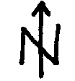
Boundaries of the cluster | 
Paved road | 
Unpaved (dirt) road
Footpath
River, creek, etc. | 
Bridge | 
Lake, pond, etc. | 
Mountains, hills | 
Water point (wells, fountain, etc.) | 
Market | 
School | 
Administrative building | 
Church, temple | 
Mosque | 
Cemetery | 
Residential structure | 
Nonresidential structure | 
Vacant structure | 
Hospital, clinic, etc. | 
Electric pole | 
Tree, bush | 

Appendix 2. Examples of mapping and listing forms

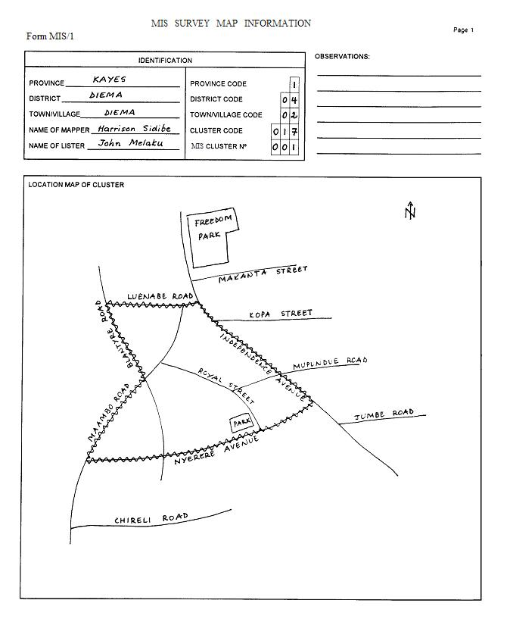

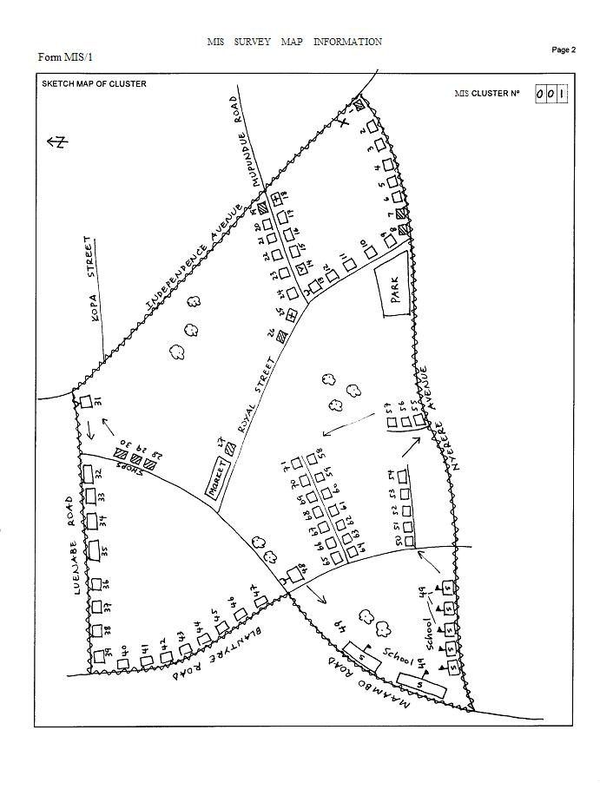

Appendix 3. Example of household listing form
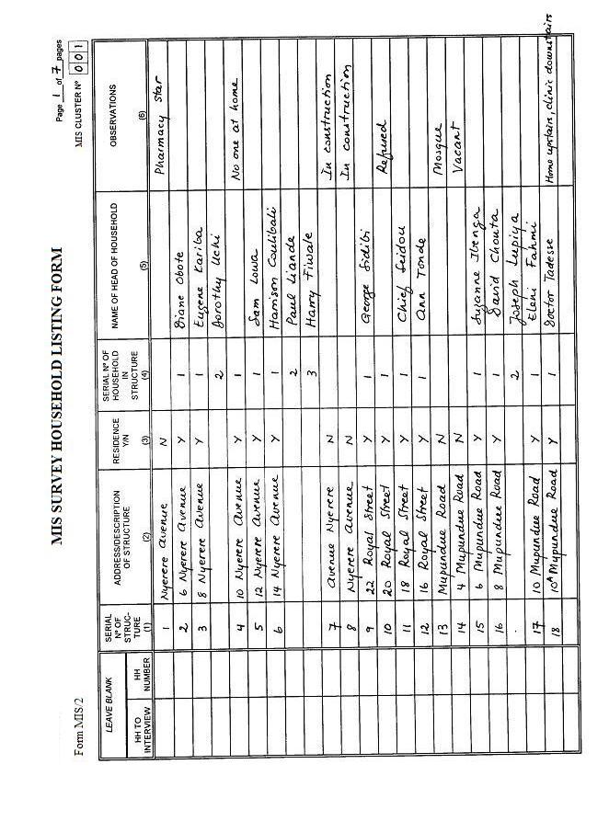

Appendix 4. Example of segmentation form
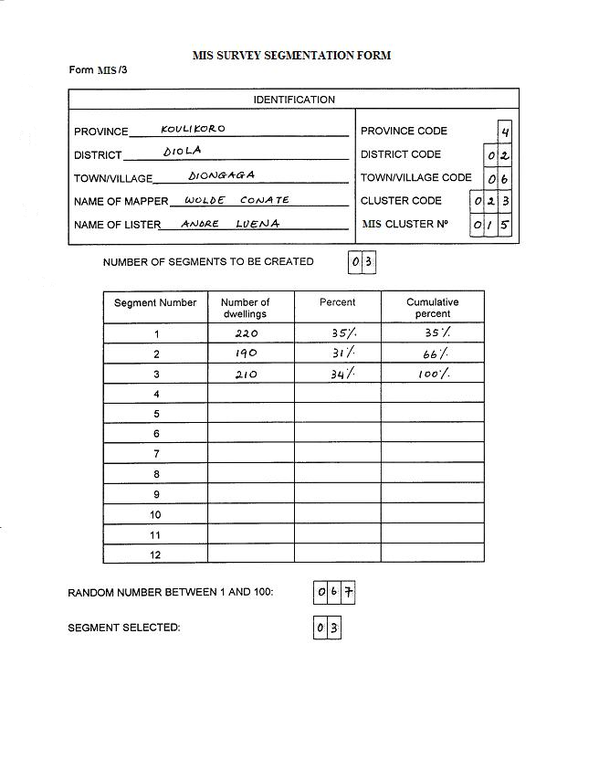

ICF International. 2012. Demographic and Health Survey Sampling and Household Listing Manual. MEASURE DHS, Calverton, Maryland, U.S.A.: ICF International.
In some surveys a decision may be made to collect GPS coordinates from each household; however, data should be aggregated to the cluster level before being made public.

